**Database project Phase-03 Submission**

**Project Idea: portfolio terrain – A dedicated social media platform for freelance and remote developers**



**Submitted by:**

**Usman Shahid (L1F22BSCS1057) &**

**Ali Hamza Sehole (L1F21BSCS0791)**

**Section: D-8**

**Submitted to:**

**Sir Afham Nazir**

use portfolio_terrain;

**DDL (data definition language) queries:**

**1. add a new column named phone_number to the users table:**

alter table users add column phone_number varchar(20) default null;

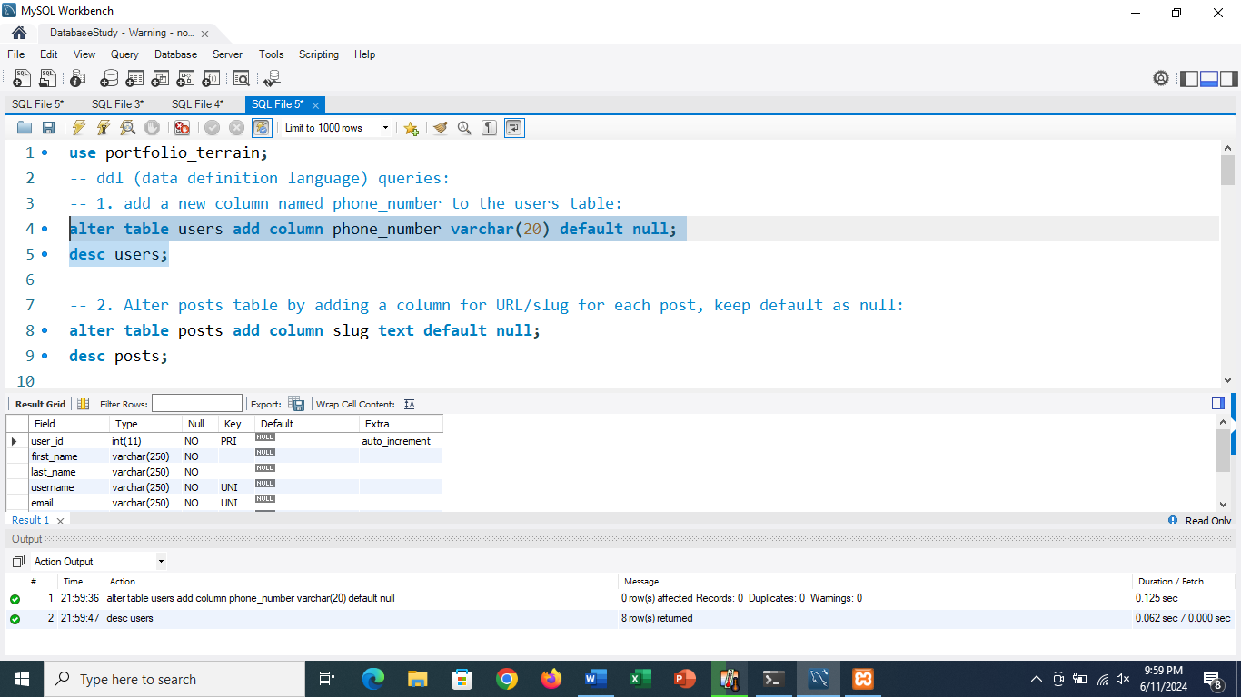

**2. Alter posts table by adding a column for URL/slug for each post, keep default as null:**

alter table posts add column slug text default null;

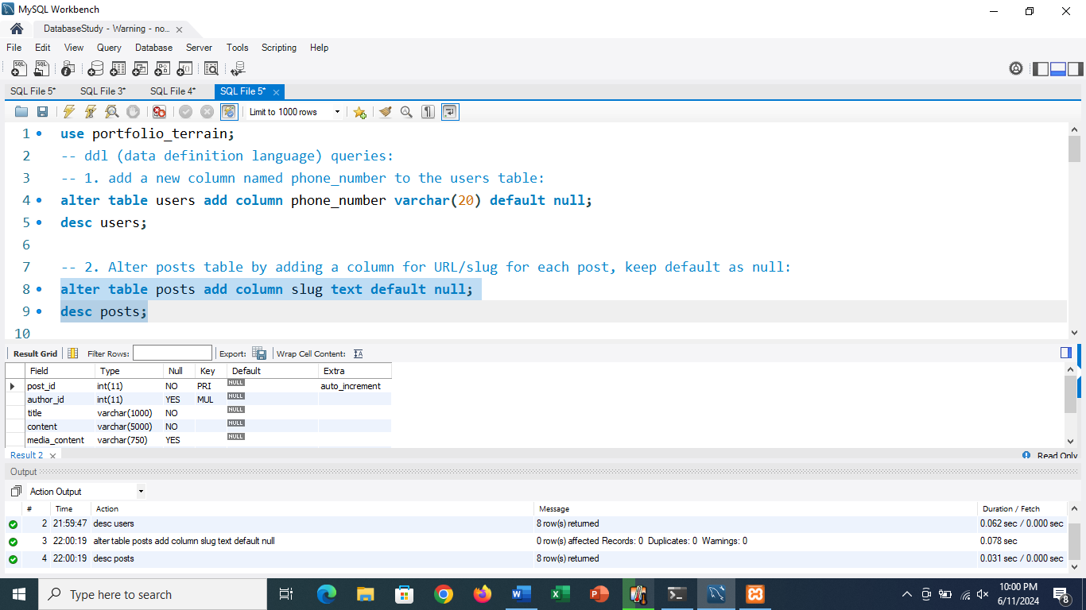

**3. create a foreign key constraint between reviews.reviewed_by and users.user_id:**

alter table reviews add constraint fk_reviewed_by foreign key (reviewed_by) references users(user_id);

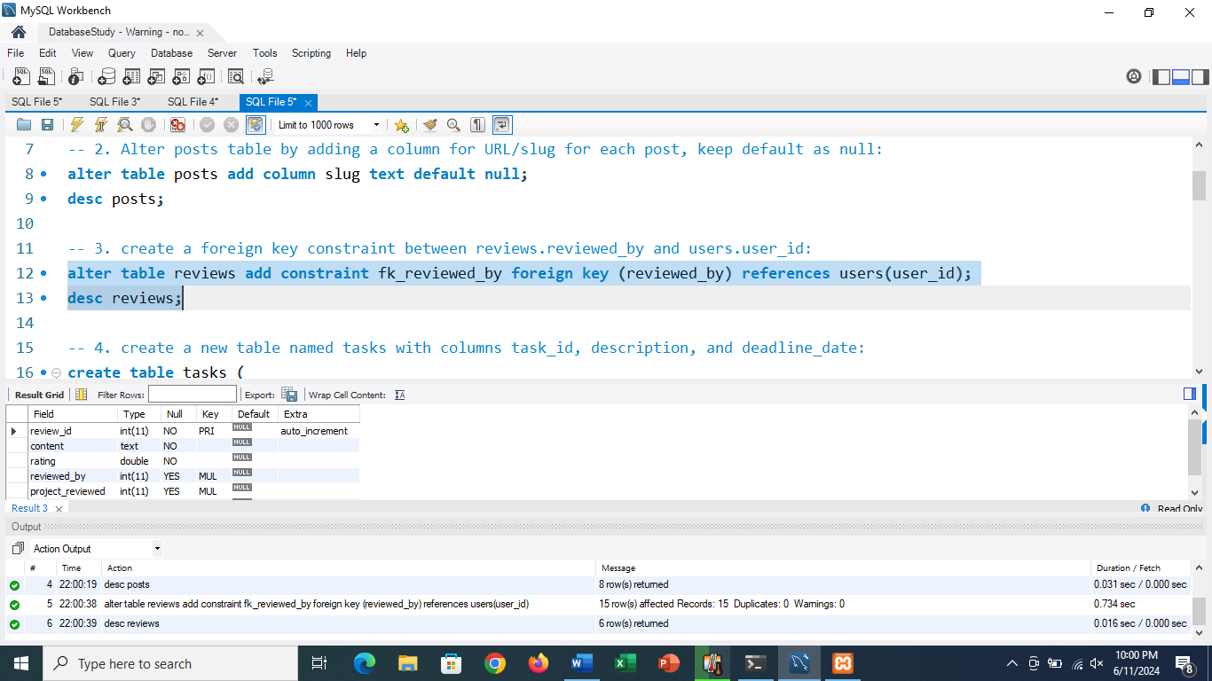

**4. create a new table named tasks with columns task_id, description, and deadline_date:**

create table tasks (

task_id int primary key auto_increment,

description varchar(500) not null,

deadline_date date

);

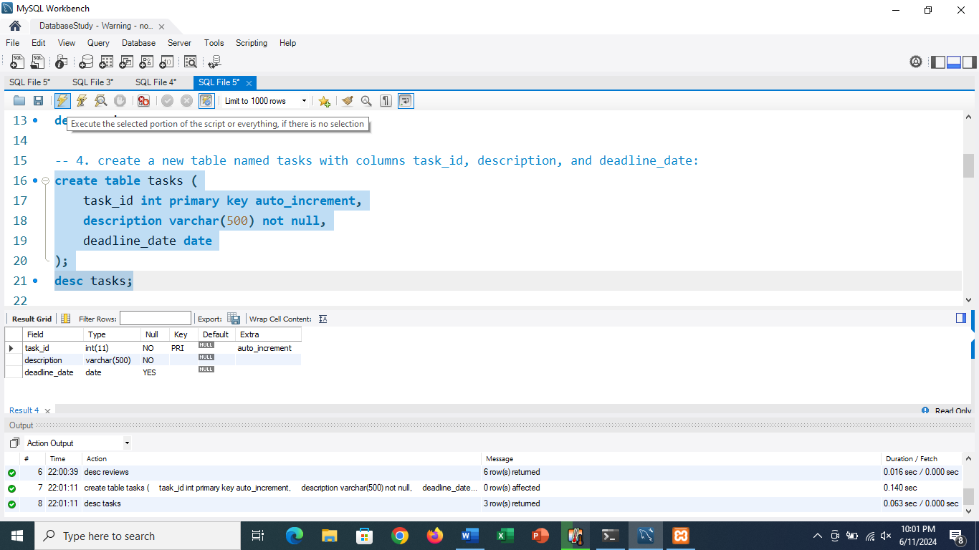

**5. modify the projects table to add a column named status:**

alter table projects add column status varchar(50) default 'pending';

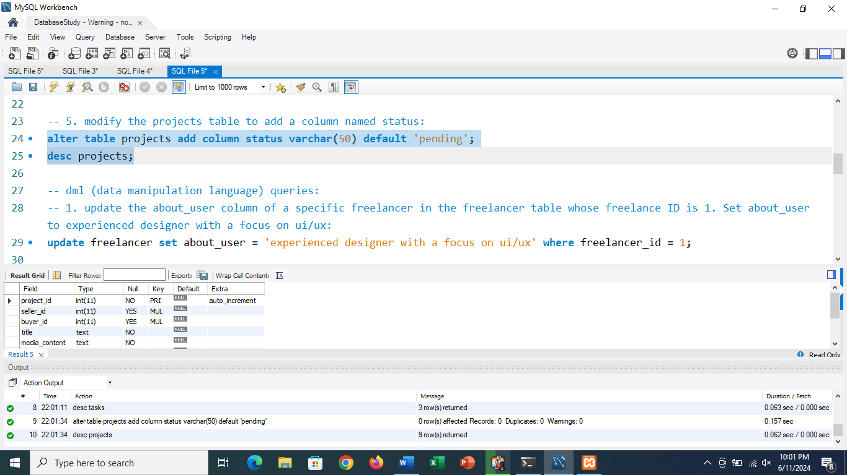

**DML (data manipulation language) queries:**

**1. update the about_user column of a specific freelancer in the freelancer table whose freelance ID is 1. Set about_user to experienced designer with a focus on ui/ux:**

update freelancer set about_user = 'experienced designer with a focus on ui/ux' where freelancer_id = 1;

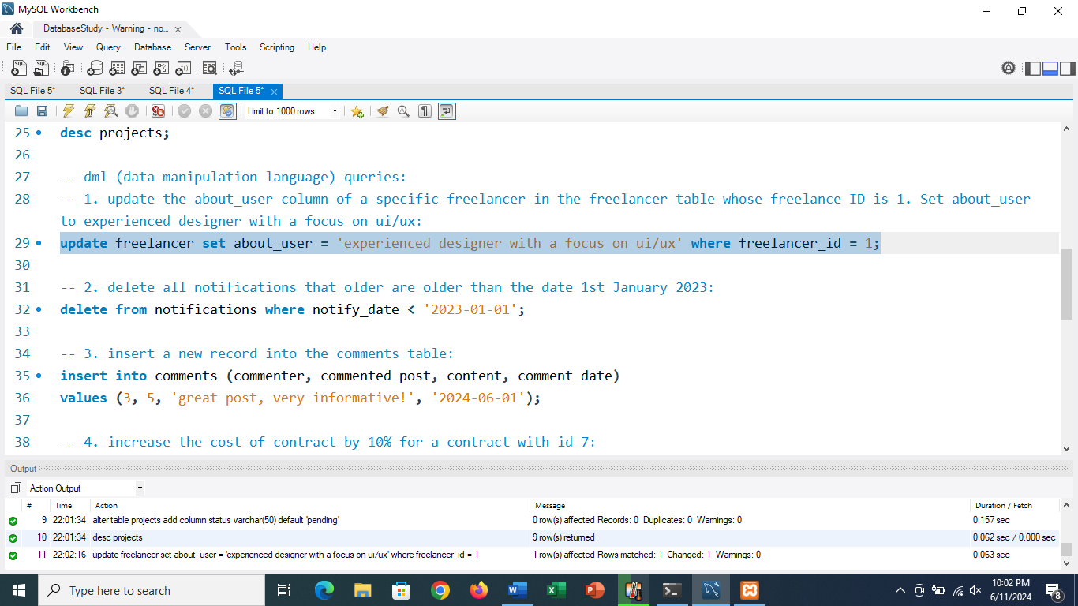

**2. delete all notifications that older are older than the date 1st January 2023:**

delete from notifications where notify_date < '2023-01-01';

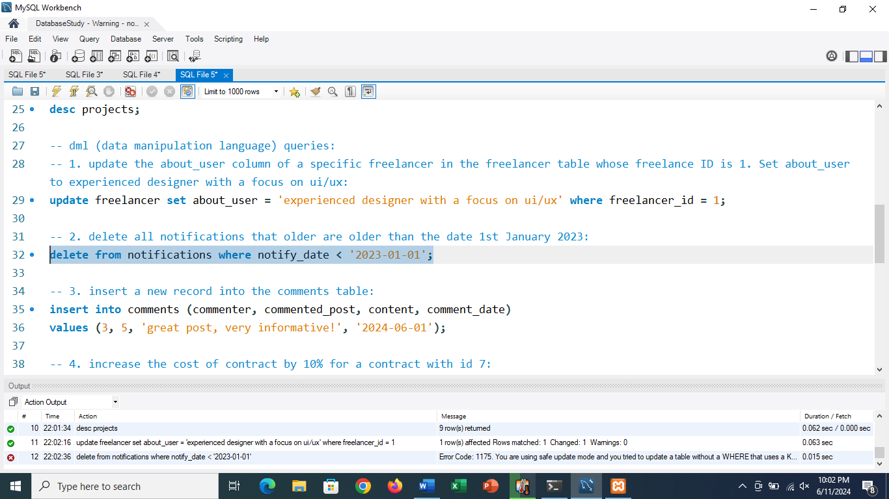

**3. insert a new record into the comments table:**

insert into comments (commenter, commented_post, content, comment_date)

values (3, 5, 'great post, very informative!', '2024-06-01');

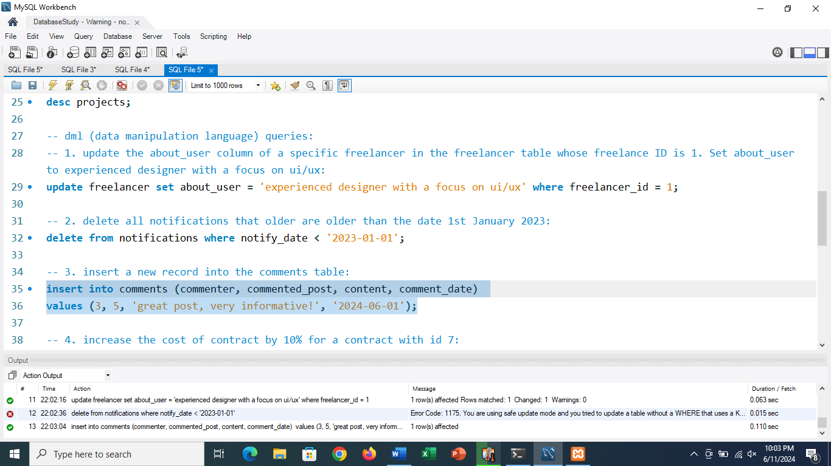

**4. increase the cost of contract by 10% for a contract with id 7:**

update contracts set cost = cost * 1.1 where contract_id = 7;

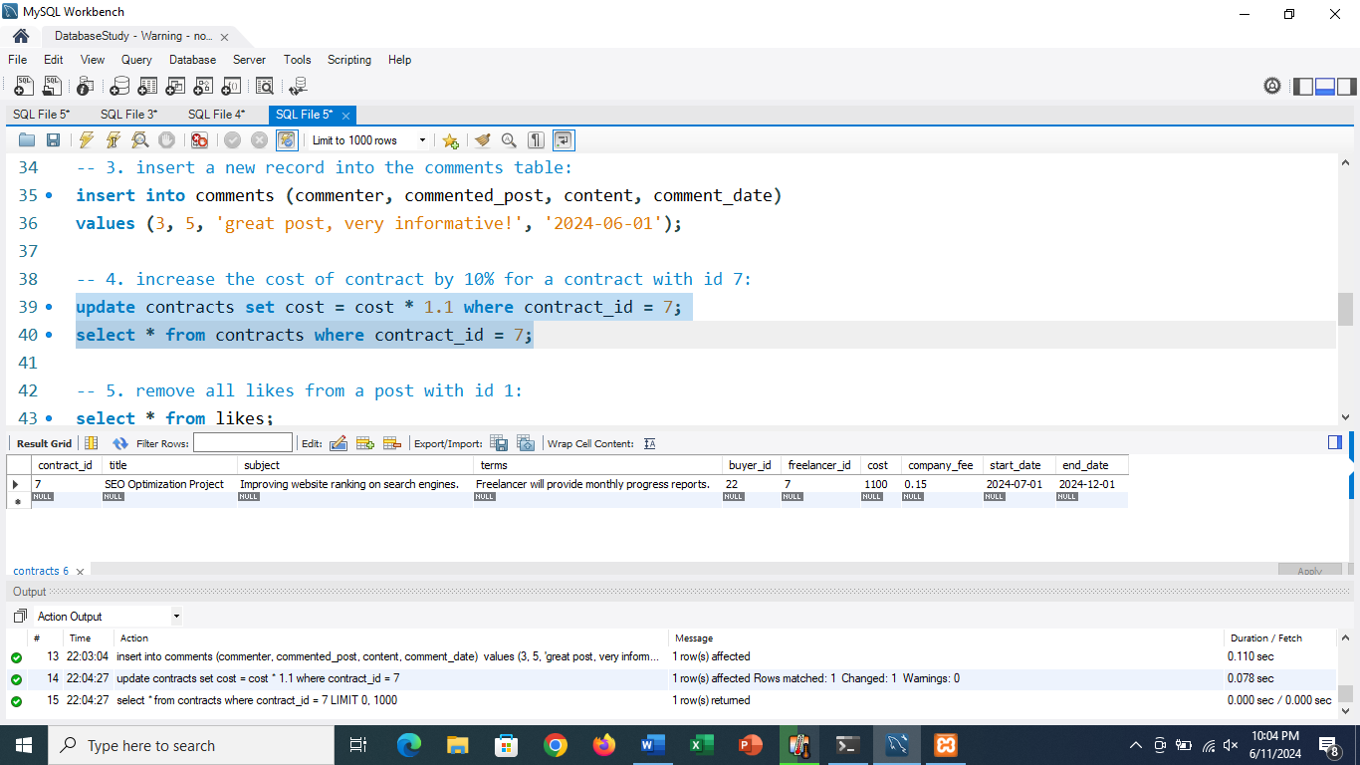

**5. remove all likes from a post with id 1:**

delete from likes where post_liked = 1;

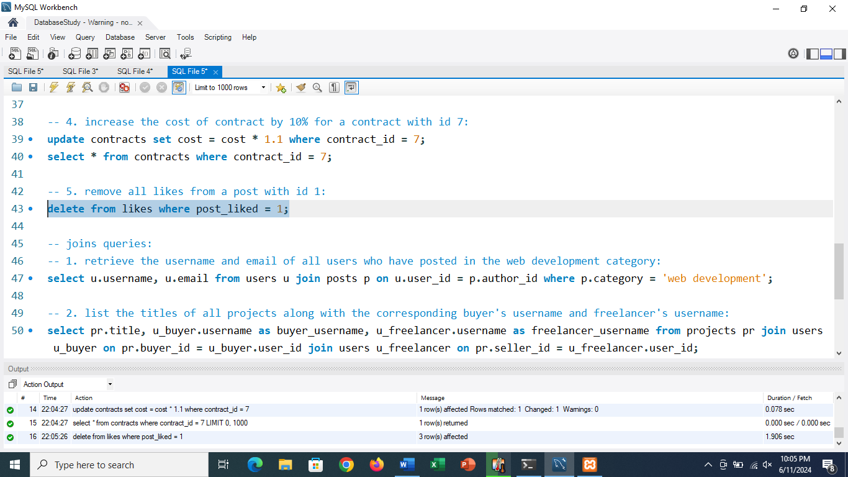

**joins queries:**

**1. retrieve the username and email of all users who have posted in the web development category:**

select u.username, u.email from users u join posts p on u.user_id = p.author_id where p.category = 'web development';

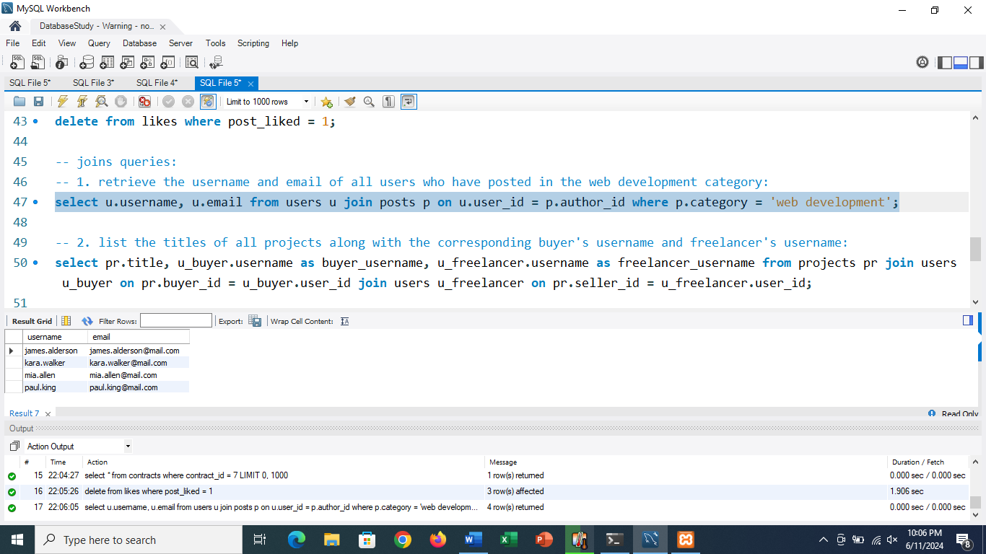

**2. list the titles of all projects along with the corresponding buyer's username and freelancer's username:**

select pr.title, u_buyer.username as buyer_username, u_freelancer.username as freelancer_username from projects pr join users u_buyer on pr.buyer_id = u_buyer.user_id join users u_freelancer on pr.seller_id = u_freelancer.user_id;

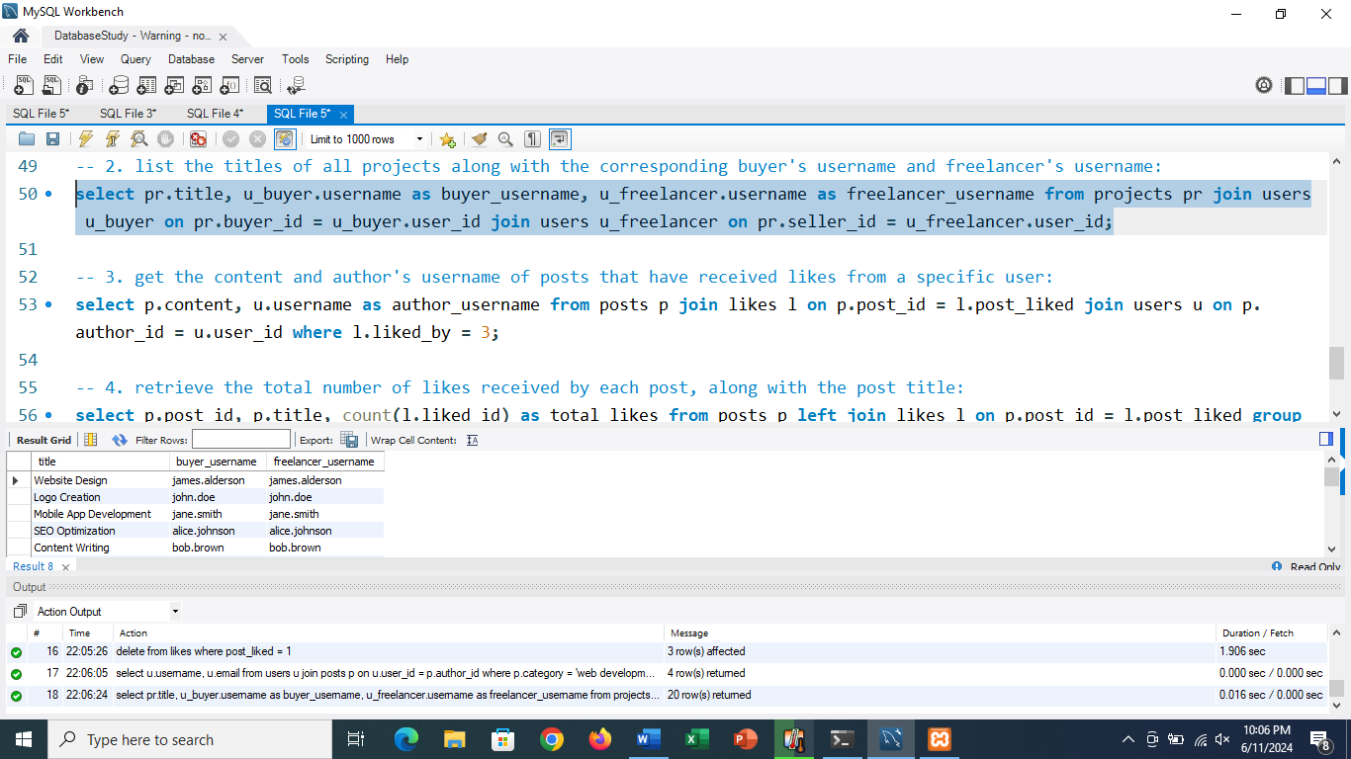

**3. get the content and author's username of posts that have received likes from a specific user:**

select p.content, u.username as author_username from posts p join likes l on p.post_id = l.post_liked join users u on p.author_id = u.user_id where l.liked_by = 3;

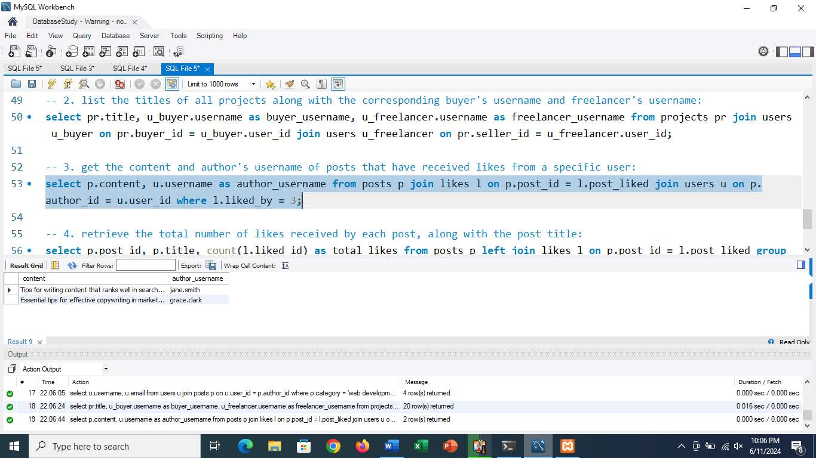

**4. retrieve the total number of likes received by each post, along with the post title:**

select p.post_id, p.title, count(l.liked_id) as total_likes from posts p left join likes l on p.post_id = l.post_liked group by p.post_id, p.title;

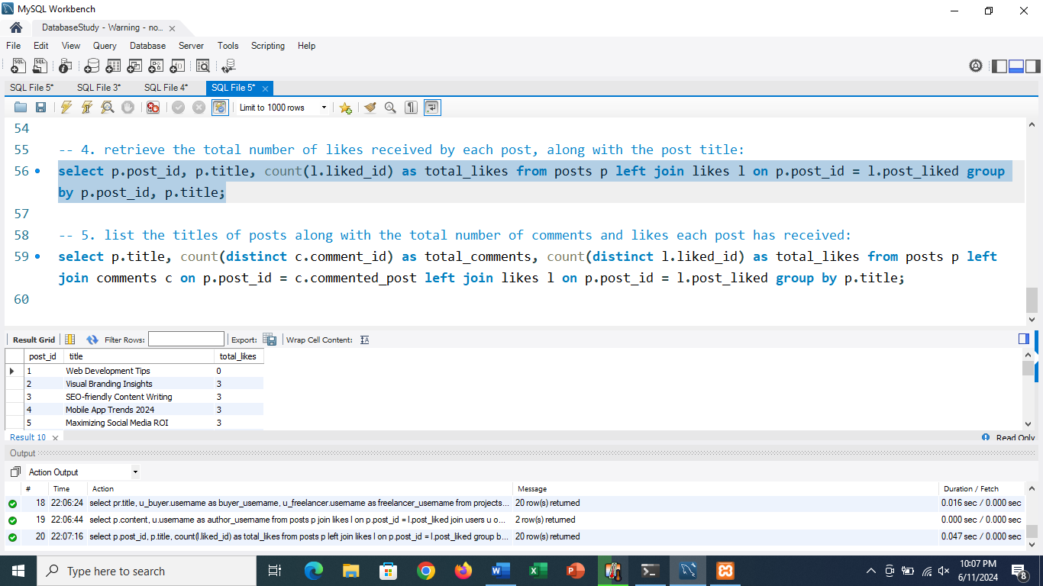

**5. list the titles of posts along with the total number of comments and likes each post has received:**

select p.title, count(distinct c.comment_id) as total_comments, count(distinct l.liked_id) as total_likes from posts p left join comments c on p.post_id = c.commented_post left join likes l on p.post_id = l.post_liked group by p.title;

